PRICE LIST 2024
Pixel PRO 2.0 C


Colour | Code | Parameters | EAN | Price | RRP | Ordered number
Grey  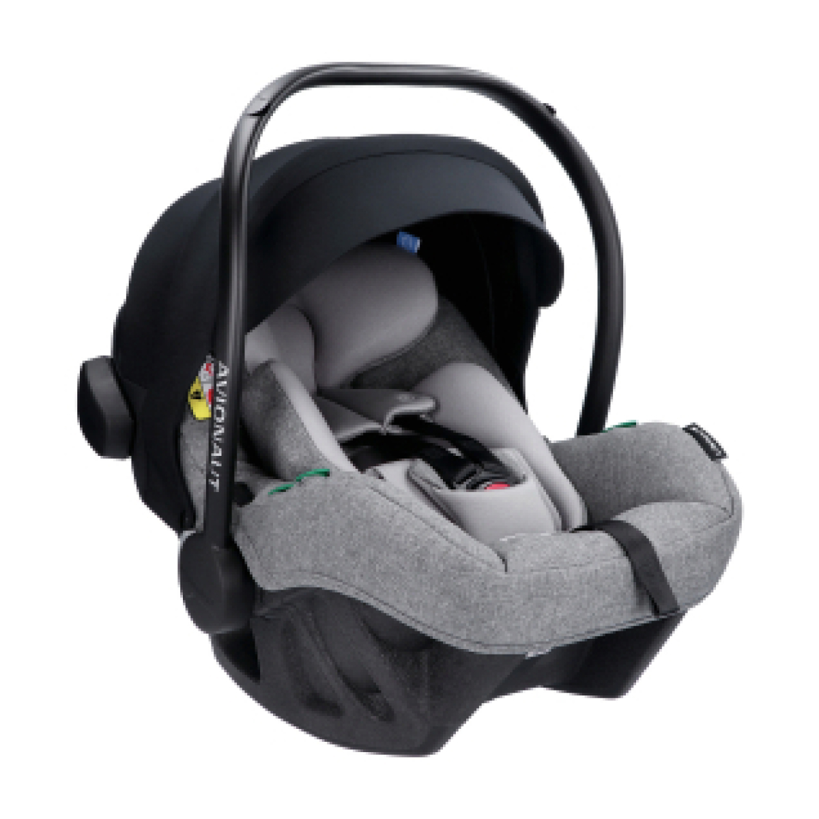 | 04136 PRO.01  2.0 C | i-Size R.129,  40-86 cm  0-13 kg | 5907603461564 | 168 € | 279 €
Beige  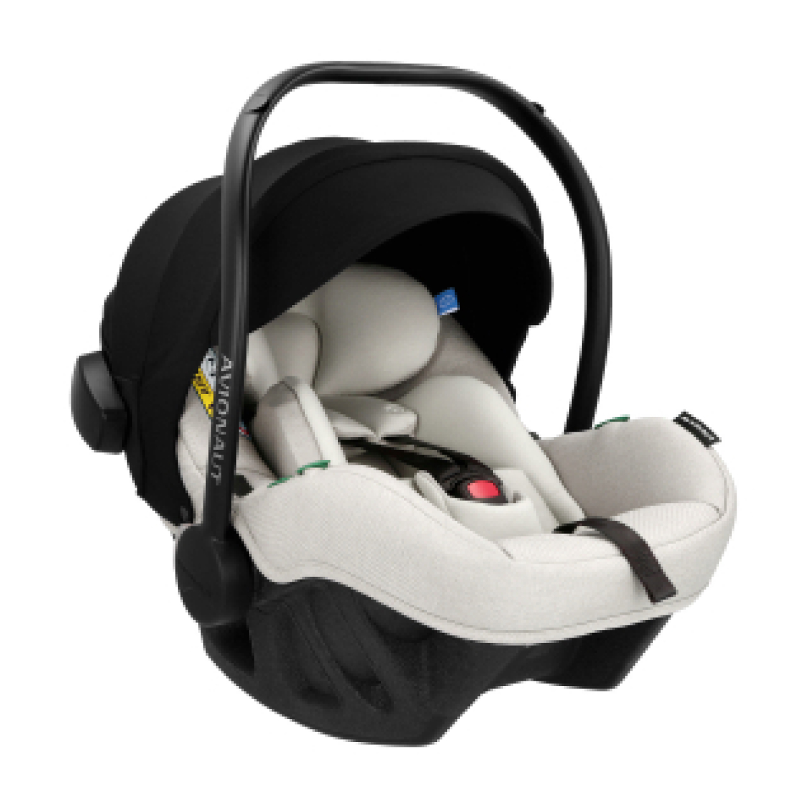 | 04137 PRO.02  2.0 C | i-Size R.129,  40-86 cm  0-13 kg | 5907603461571 | 168 € | 279 €
Black  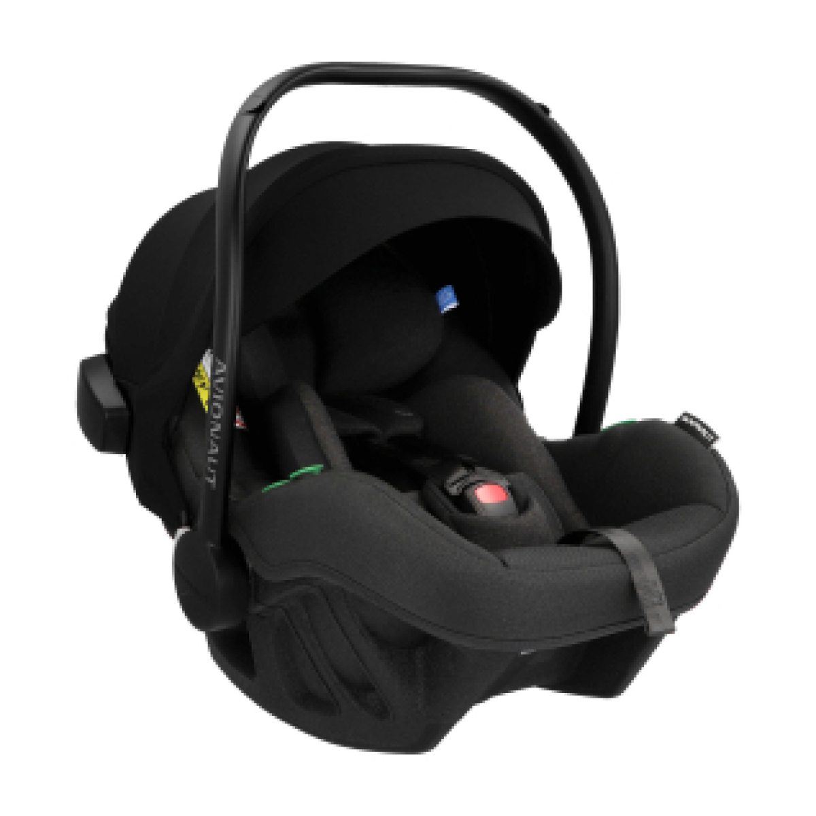 | 04138 PRO.03  2.0 C | i-Size R.129,  40-86 cm  0-13 kg | 5907603461588 | 168 € | 279 €
Navy  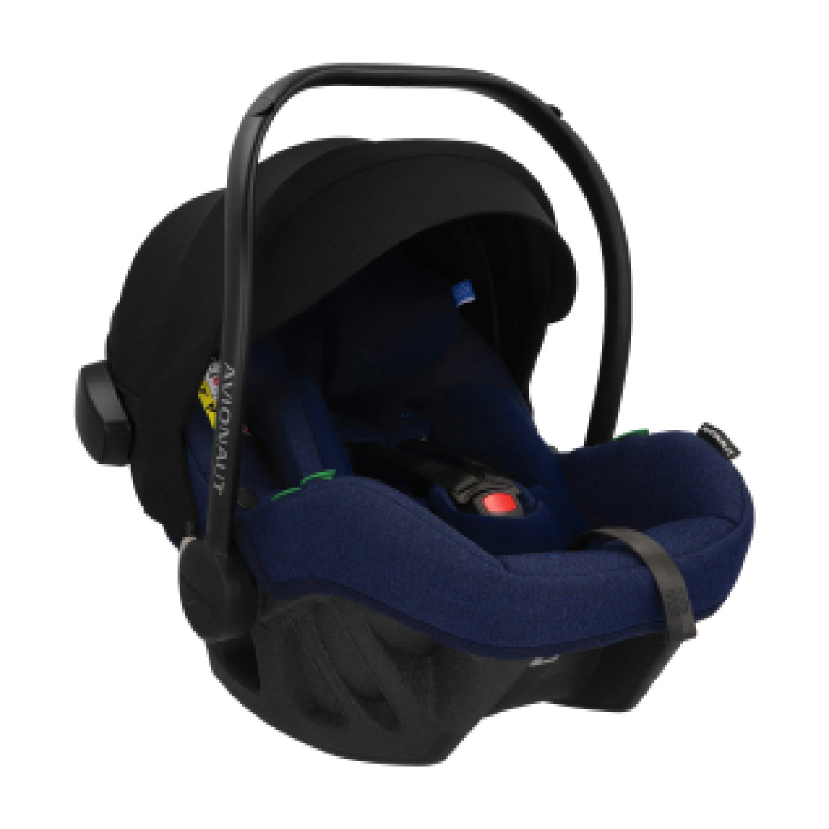 | 04139 PRO.04  2.0 C | i-Size R.129,  40-86 cm  0-13 kg | 5907603461595 | 168 € | 279 €
Pink  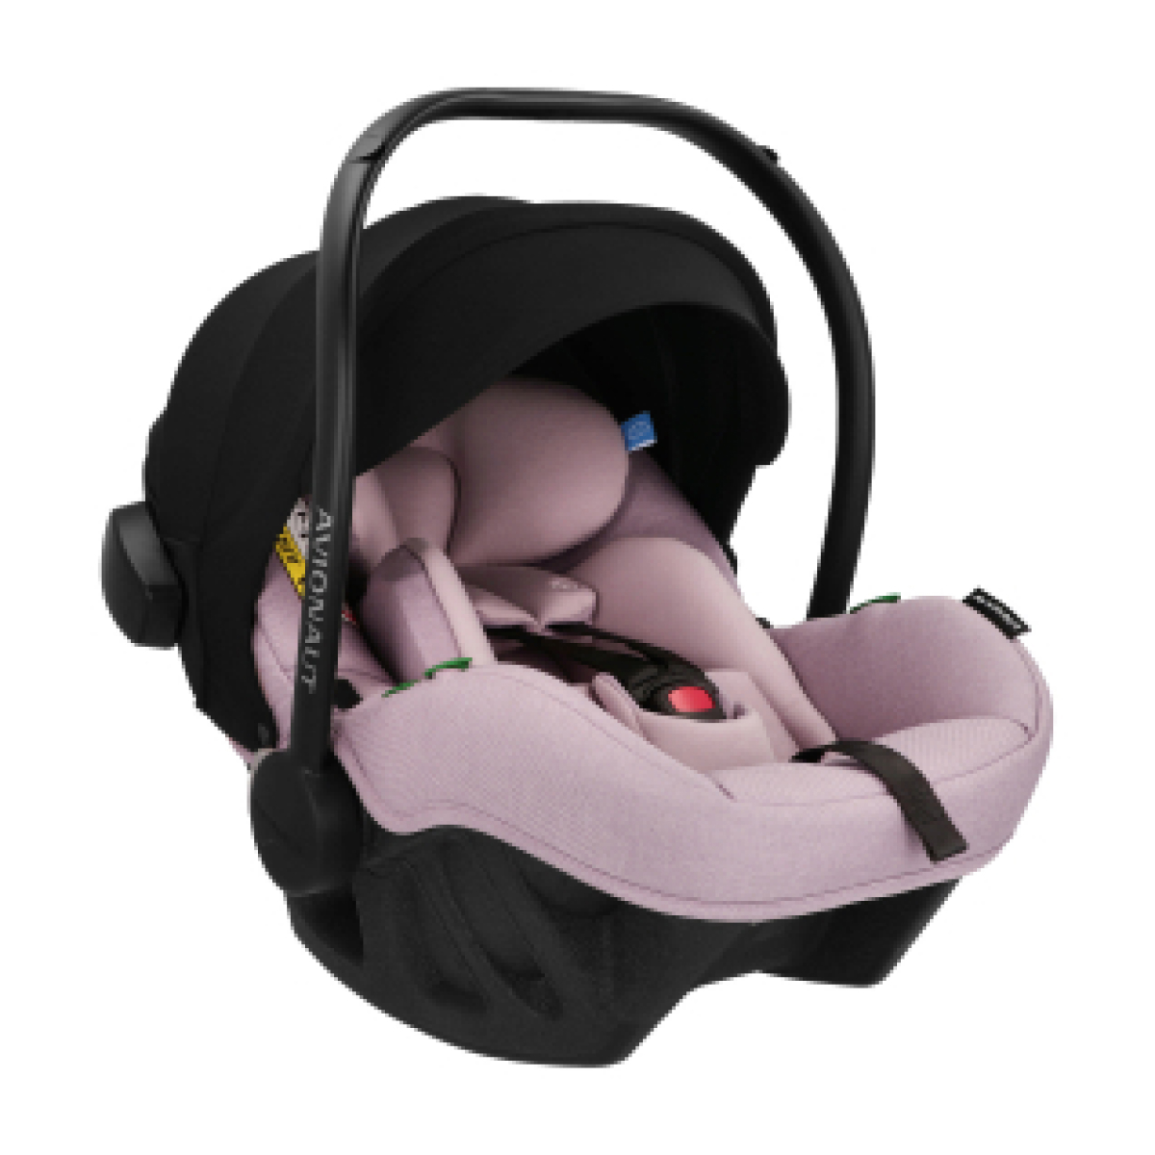 | 04140 PRO.05  2.0 C | i-Size R.129,  40-86 cm  0-13 kg | 5907603461601 | 168 € | 279 €
Mint  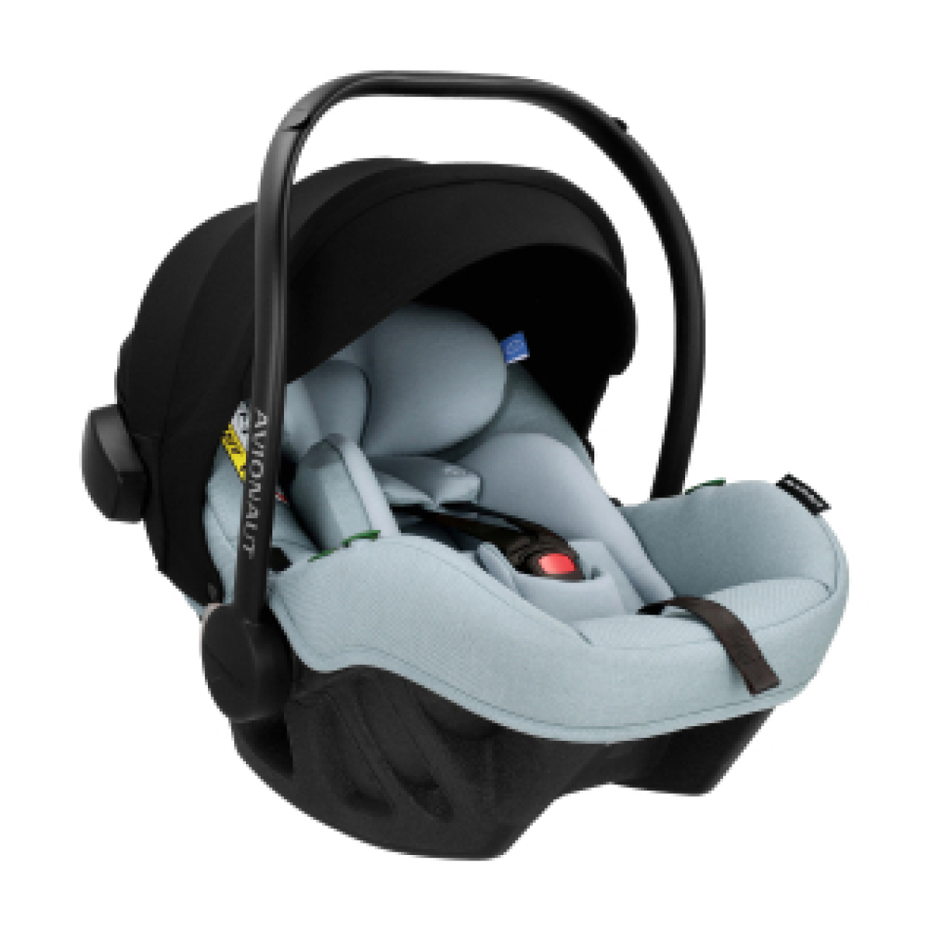 | 04141 PRO.06  2.0 C | i-Size R.129,  40-86 cm  0-13 kg | 5907603461618 | 168 € | 279 €
Limited Edition  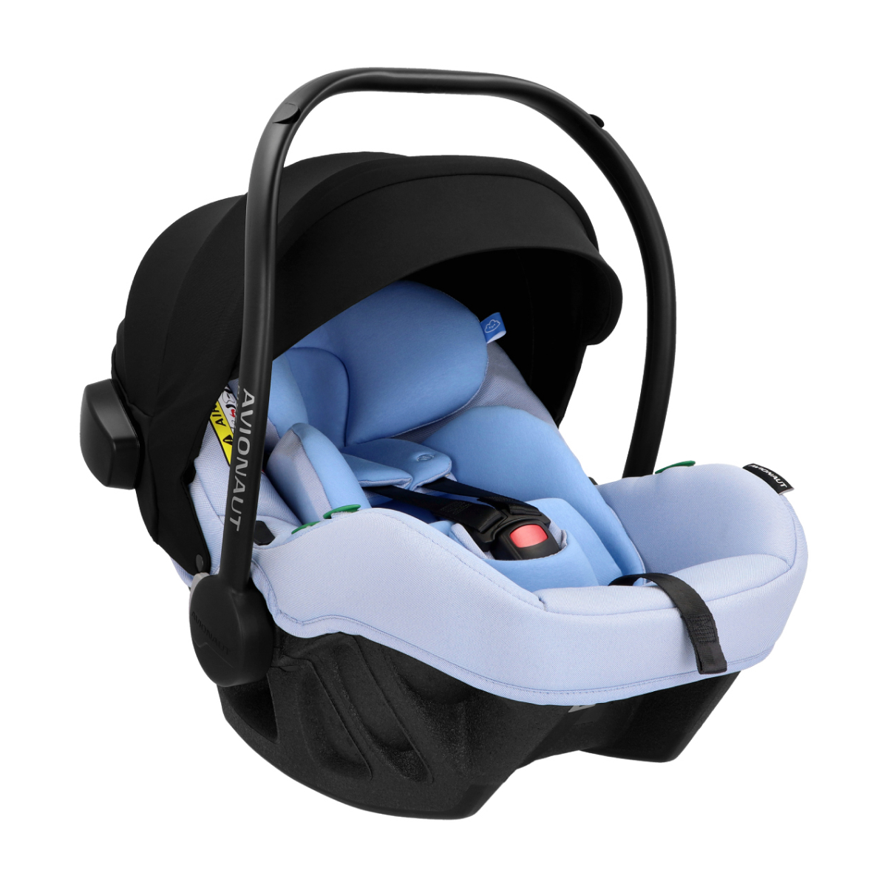 | 04415 PRO.07  2.0 C | i-Size R.129,  40-86 cm  0-13 kg | 5907603461700 | 168 € | 279 €

MaxSpace
Comfort System +

Colour | Code | Parameters | EAN | Price | RRP | Ordered number
Grey  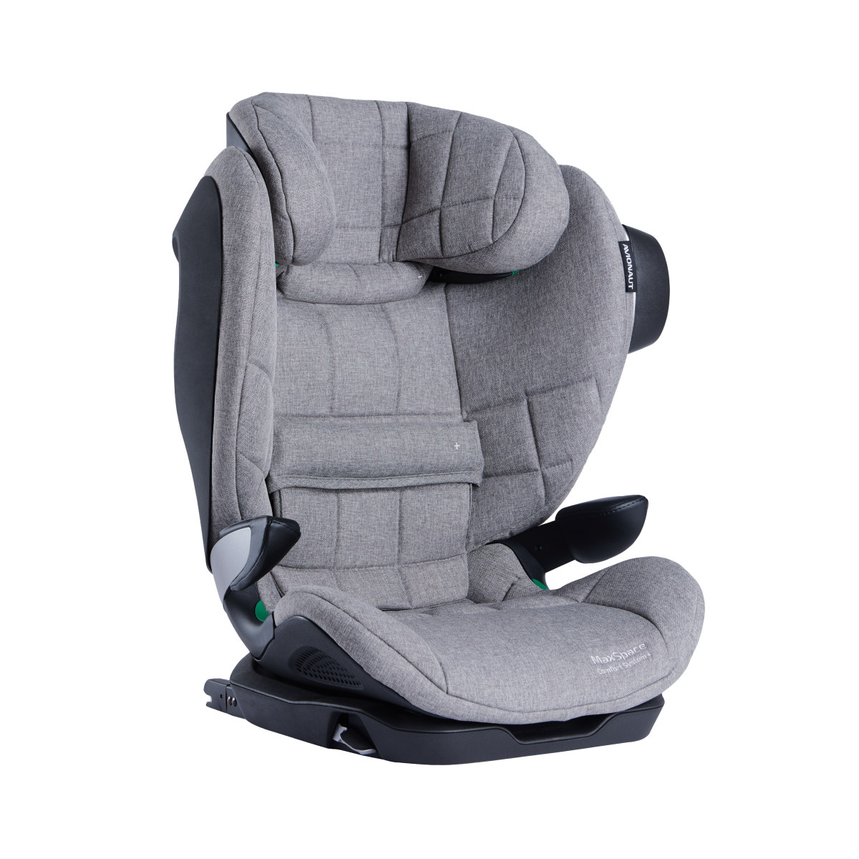 | AV-360/MAX.01 | i-Size R.129,  100-150 cm | 5907603464022 | 200 € | 319 €
Beige  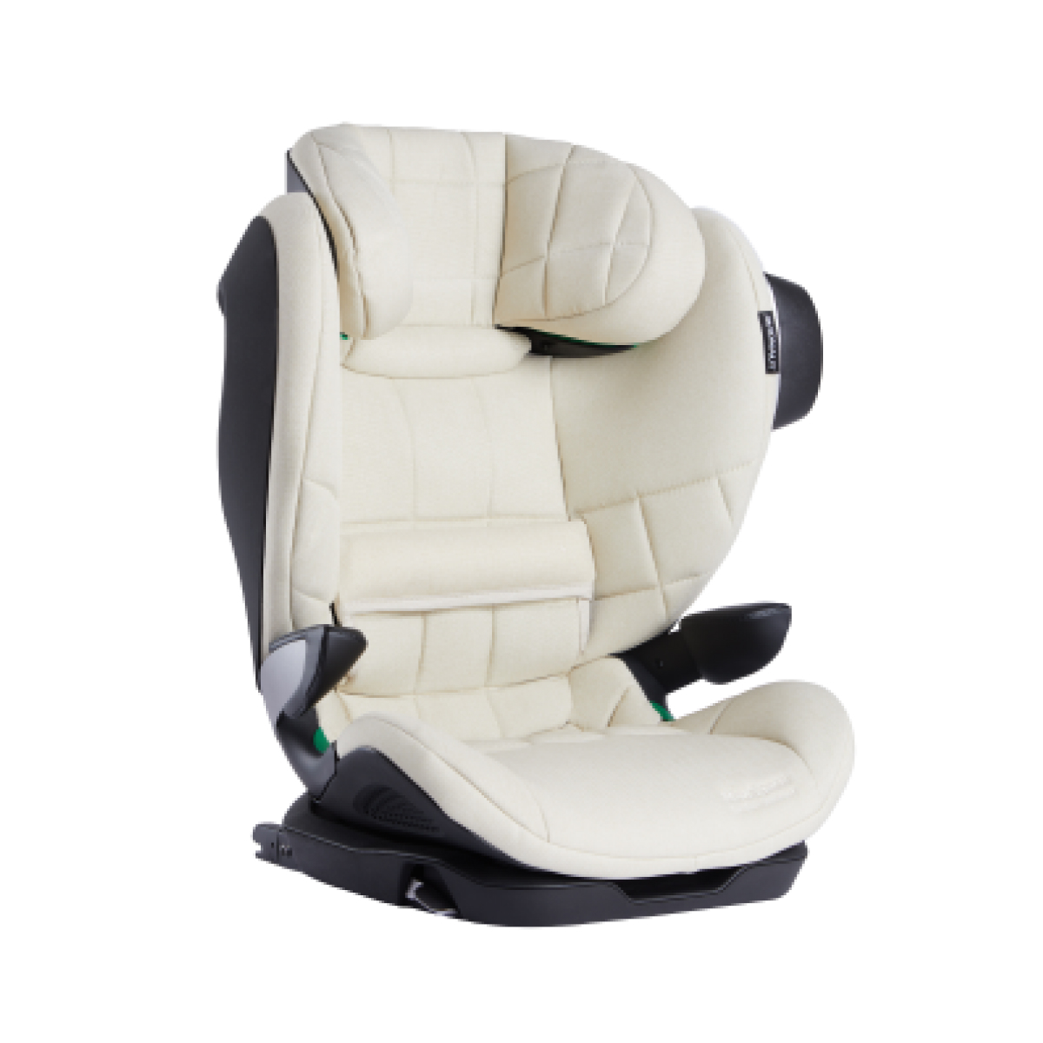 | AV-360/MAX.02 | i-Size R.129,  100-150 cm | 5907603463124 | 200 € | 319 €
Black  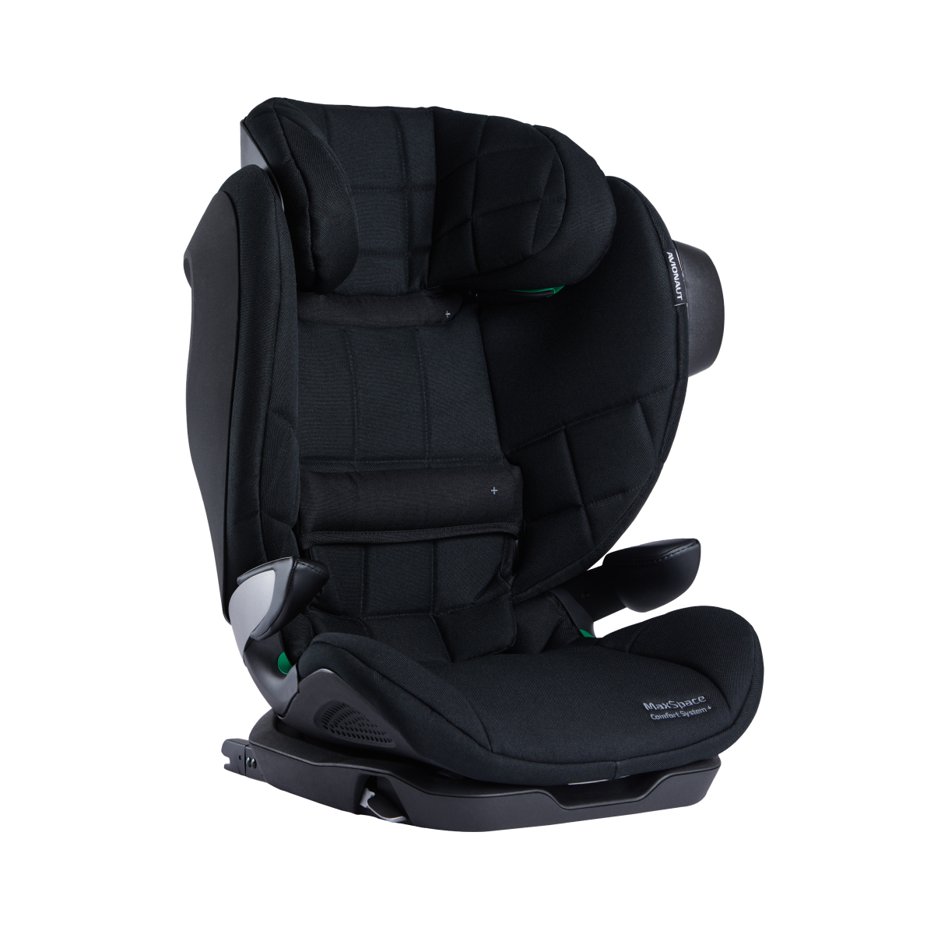 | AV-360/MAX.03 | i-Size R.129,  100-150 cm | 5907603463131 | 200 € | 319 €
Navy  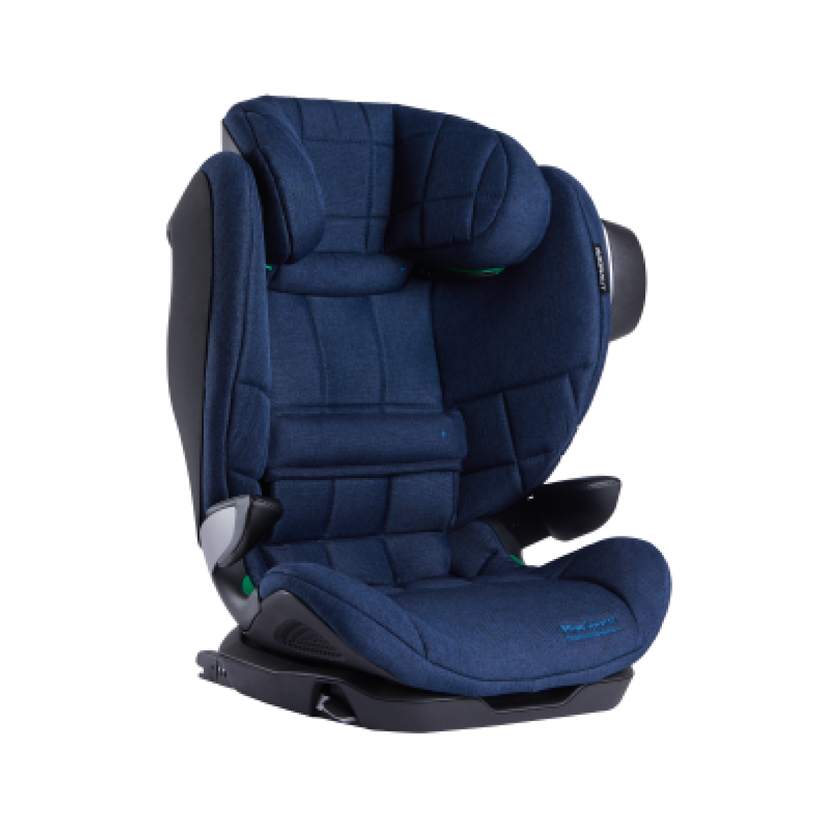 | AV-360/MAX.04 | i-Size R.129,  100-150 cm | 5907603463148 | 200 € | 319 €
Pink  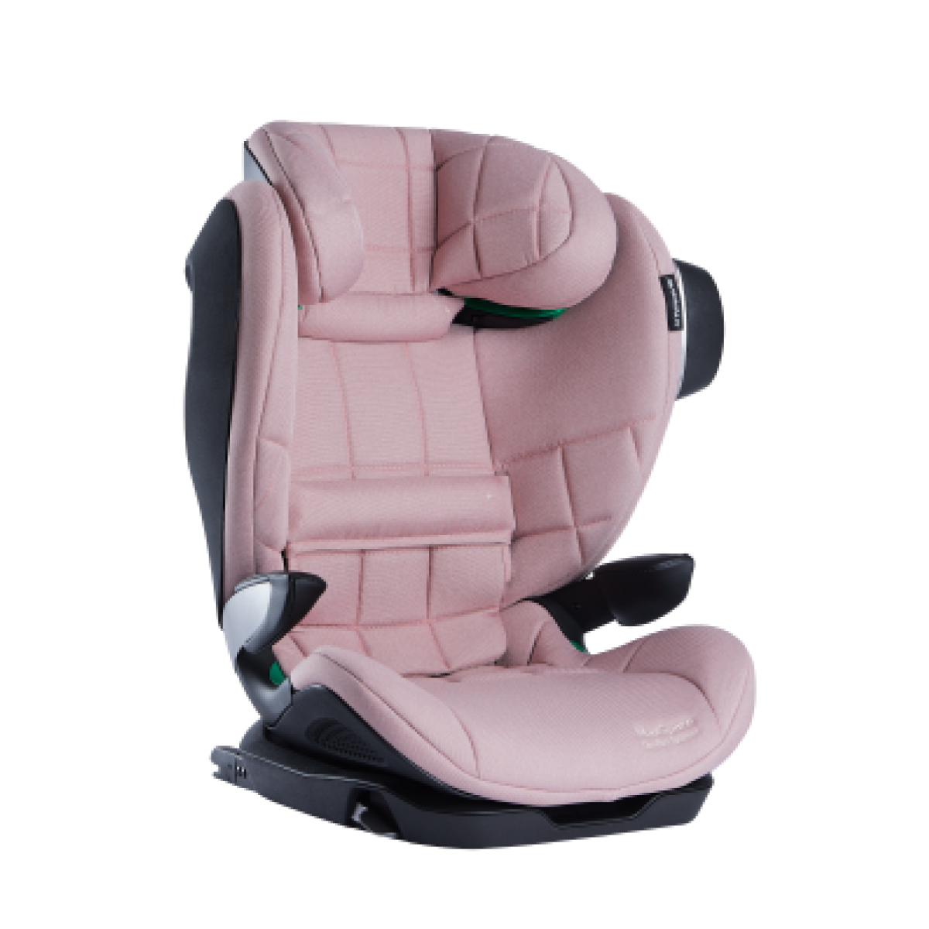 | AV-360/MAX.05 | i-Size R.129,  100-150 cm | 5907603463155 | 200 € | 319 €
Mint  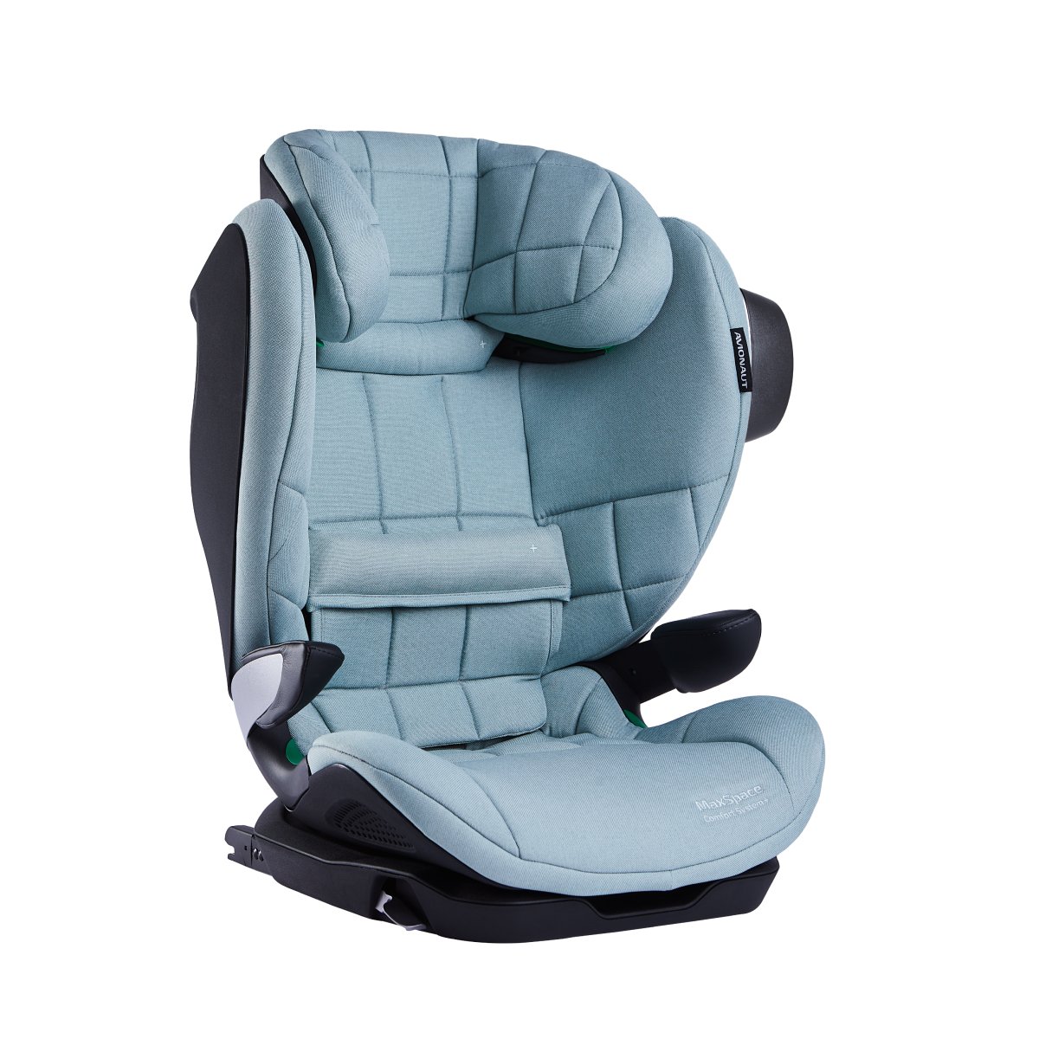 | AV-360/MAX.06 | i-Size R.129,  100-150 cm | 5907603460864 | 200 € | 319 €

Cosmo

Colour | Code | Parameters | EAN | Price | RRP | Ordered number
Grey  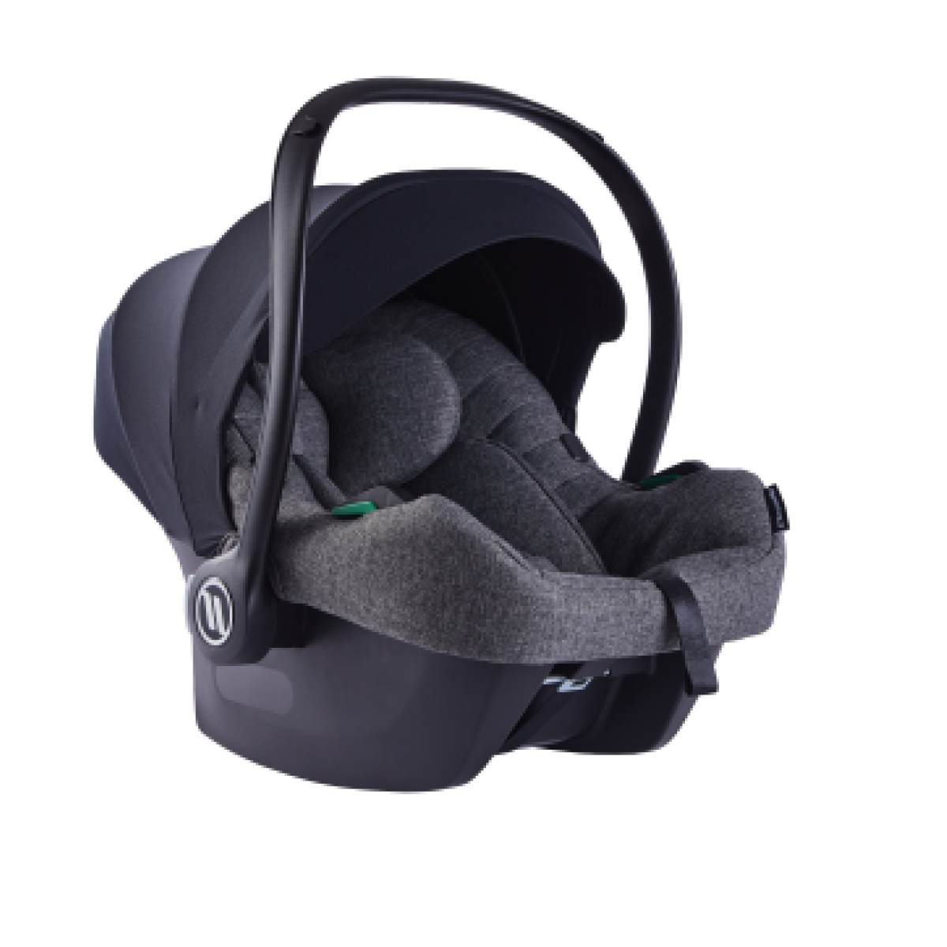 | AV-305.C.01 | i-Size R.129,  40-87 cm  0-13 kg | 5907603463926 | 119 € | 184 €
Mint  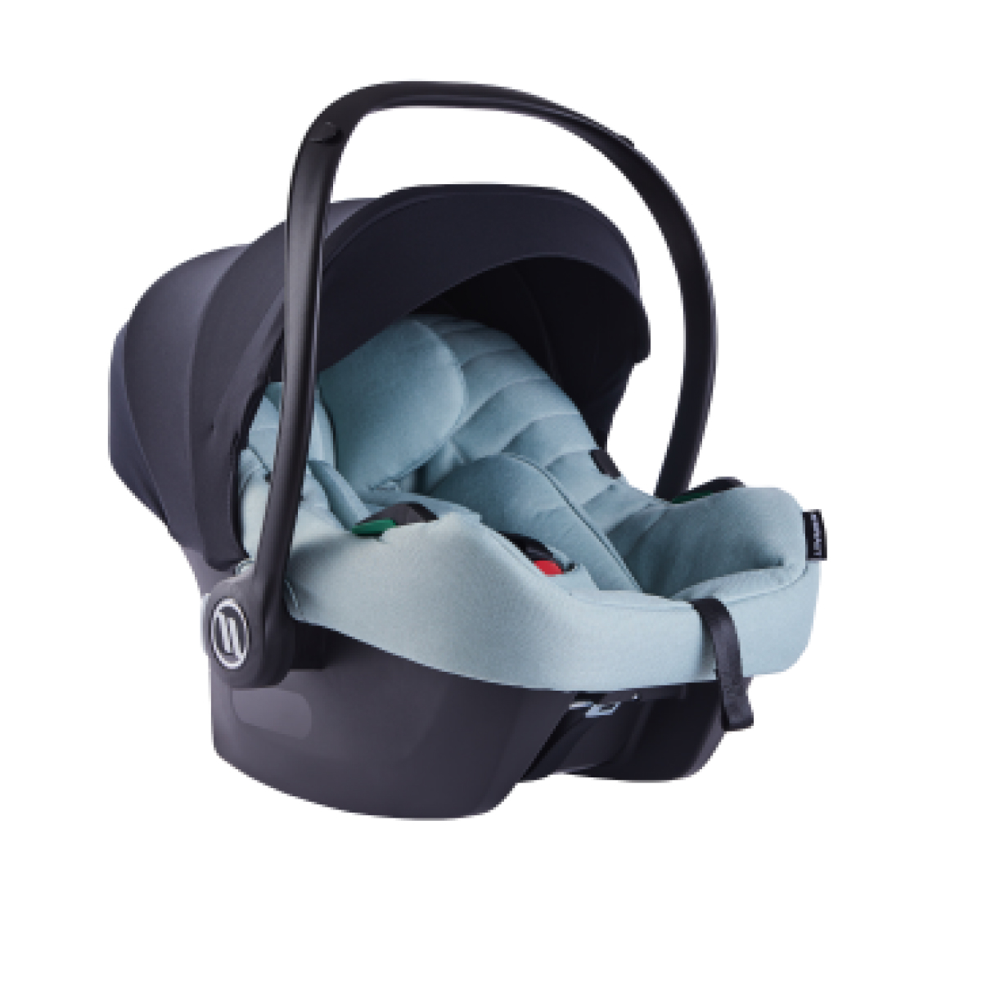 | AV-305.C.02 | i-Size R.129,  40-87 cm  0-13 kg | 5907603463902 | 119 € | 184 €
Black  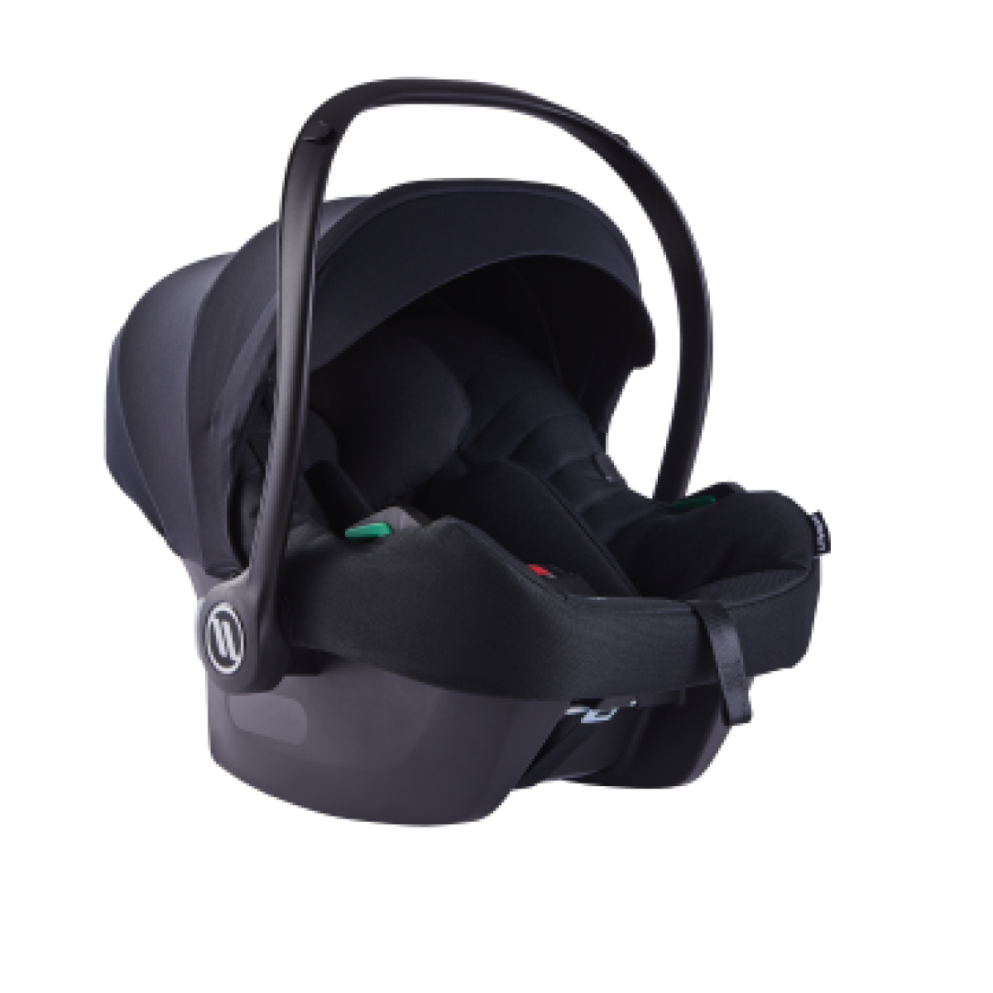 | AV-305.C.03 | i-Size R.129,  40-87 cm  0-13 kg | 5907603463889 | 119 € | 184 €
Jeans  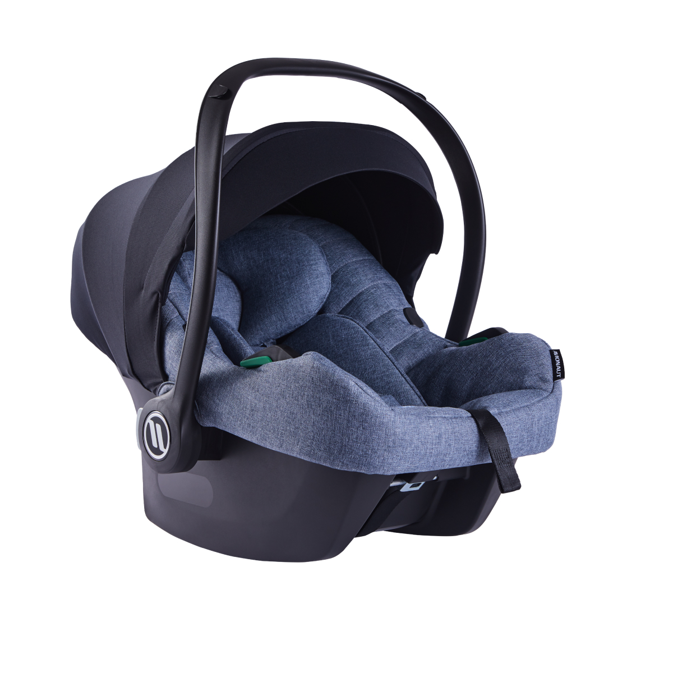 | AV-305.C.04 | i-Size R.129,  40-87 cm  0-13 kg | 5907603463919 | 119 € | 184 €
Red  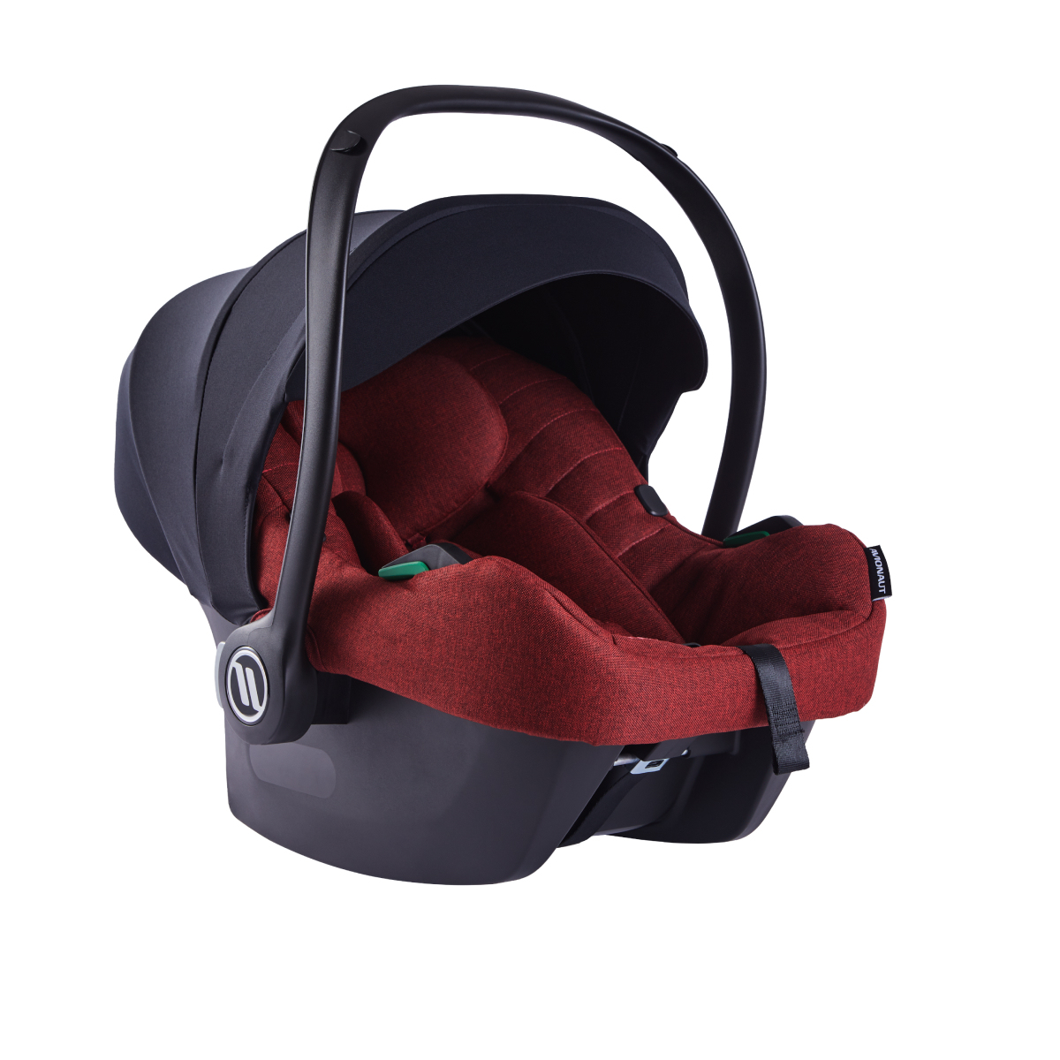 | AV-305.C.05 | i-Size R.129,  40-87 cm  0-13 kg | 5907603463896 | 119 € | 184 €

AeroFIX 2.0 C


Colour | Code | Parameters | EAN | Price | RRP | Ordered number
Grey  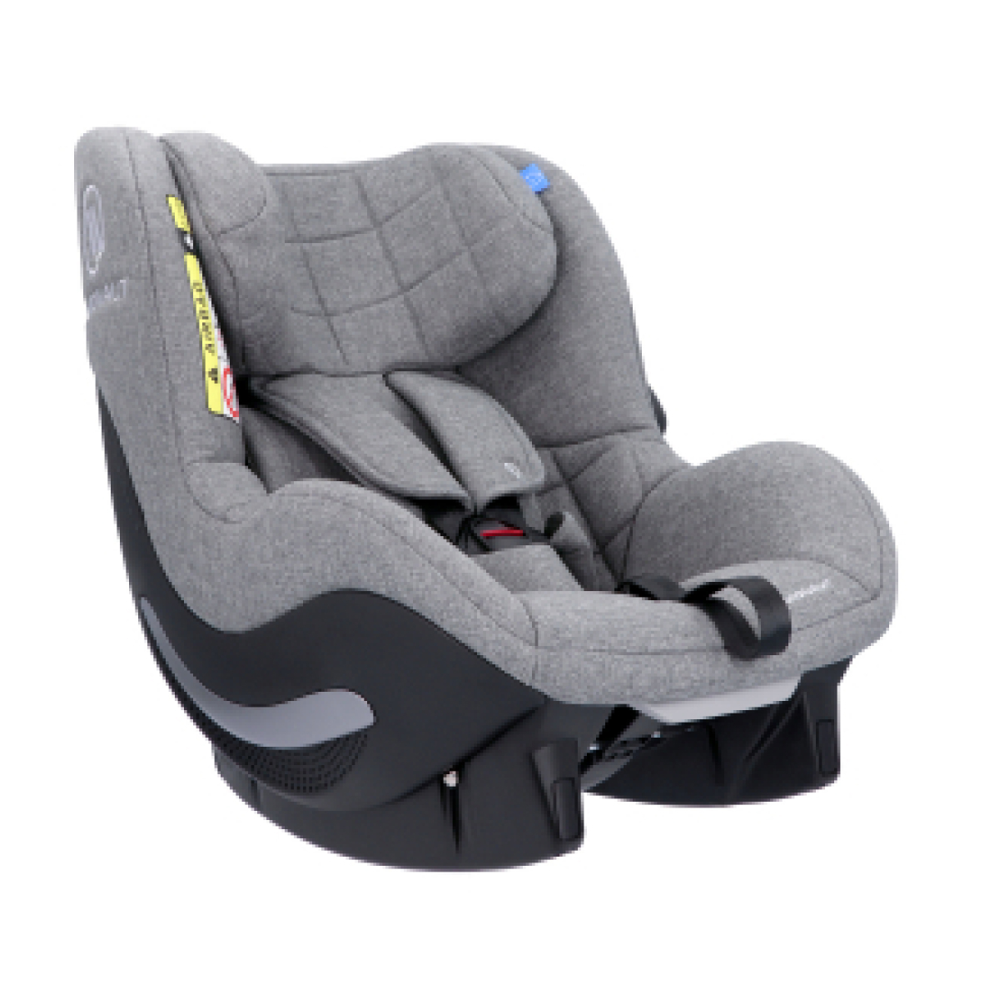 | 04178 AF.01  2.0 C | i-Size R.129,  67-105 cm  9-17,5 kg | 5907603461434 | 195 € | 329 €
Beige  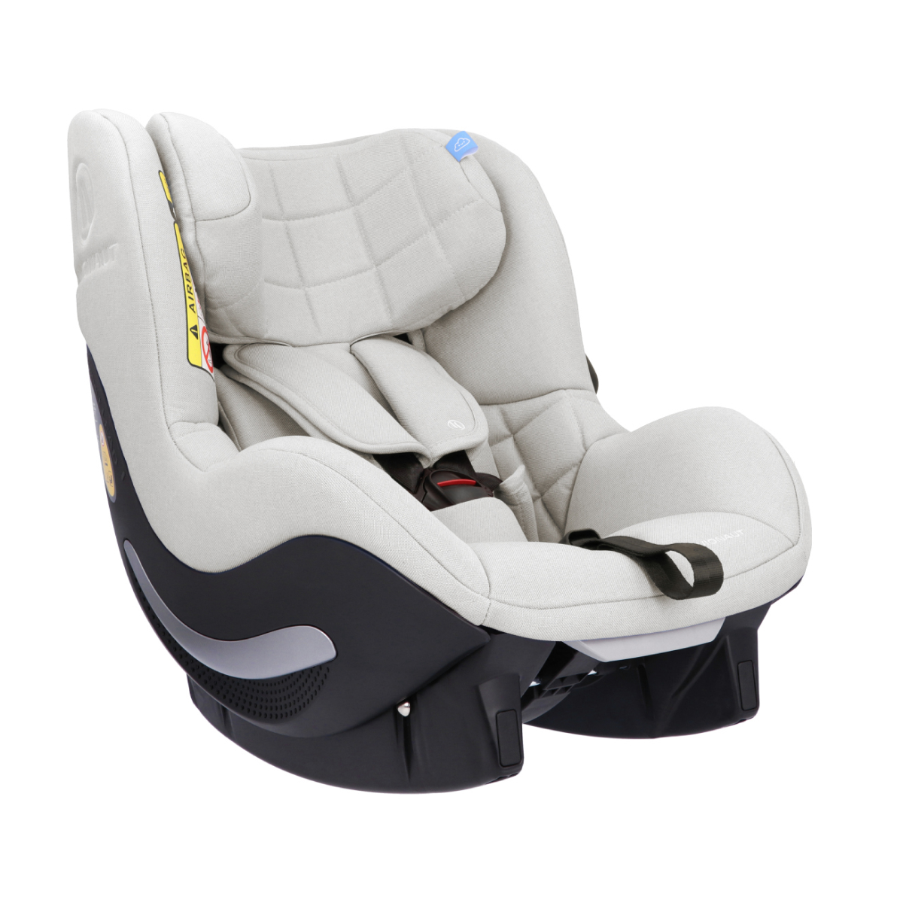 | 04179 AF.02  2.0 C | i-Size R.129,  67-105 cm  9-17,5 kg | 5907603461441 | 195 € | 329 €
Black  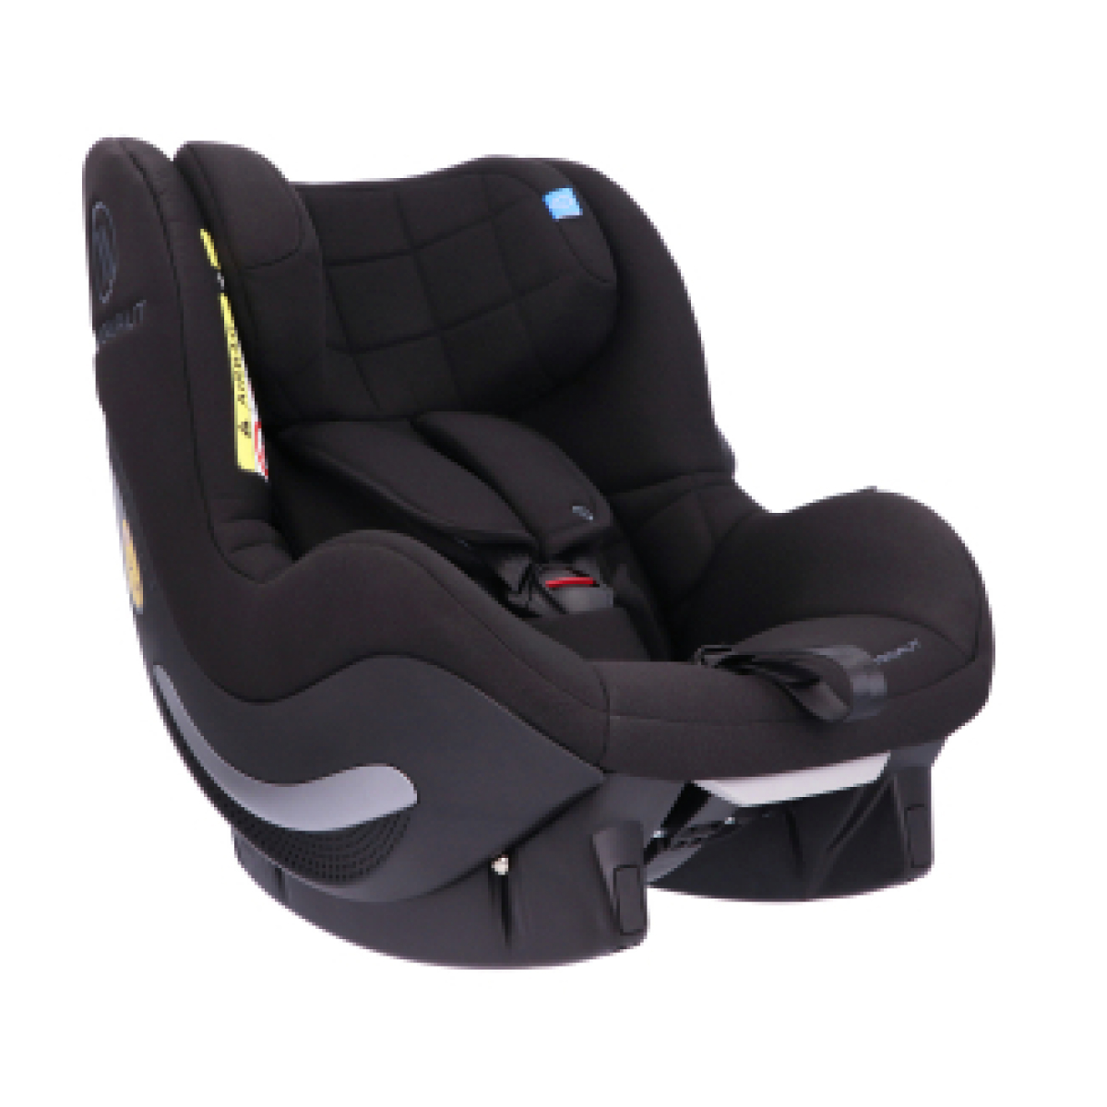 | 04180 AF.03  2.0 C | i-Size R.129,  67-105 cm  9-17,5 kg | 5907603461458 | 195 € | 329 €
Navy  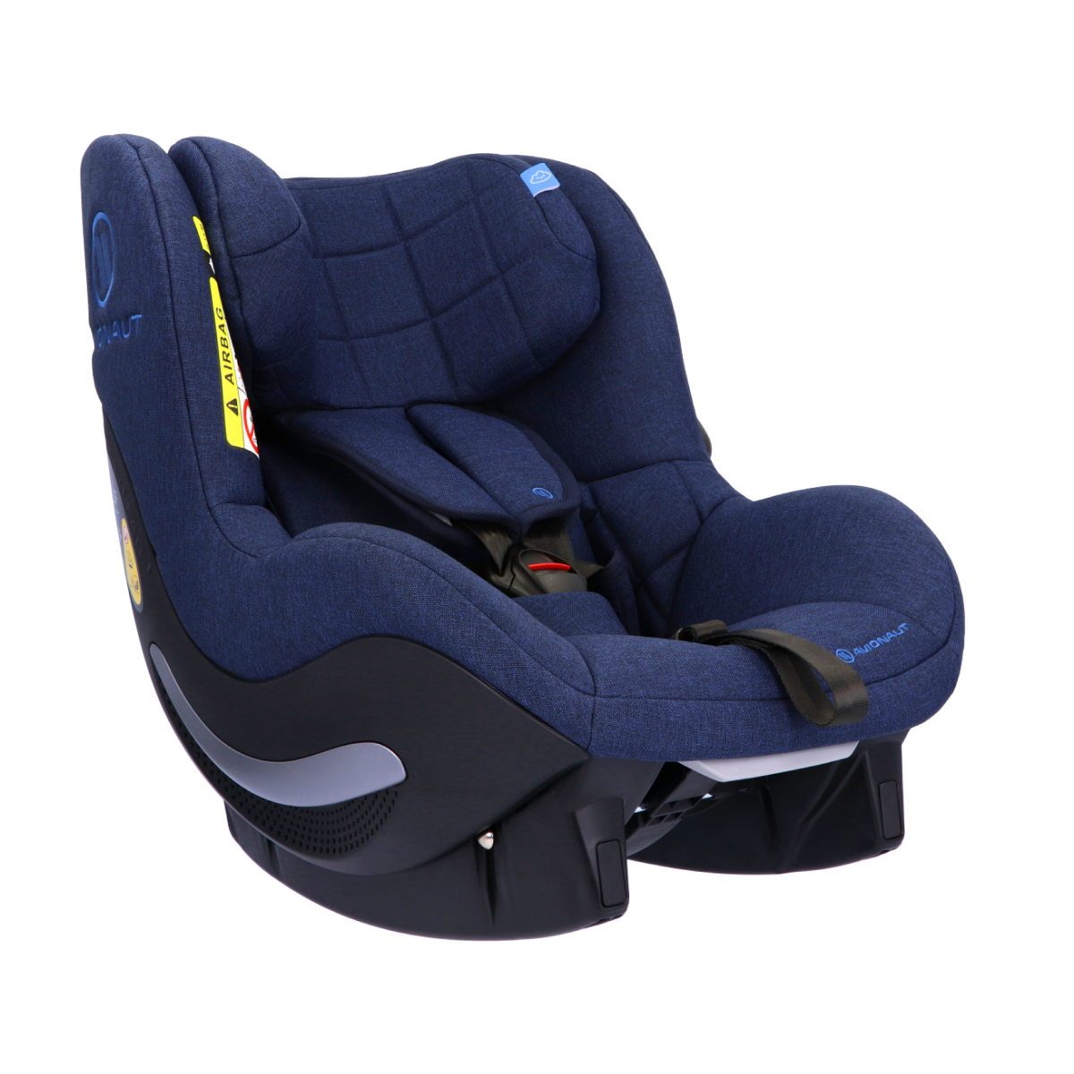 | 04181 AF.04  2.0 C | i-Size R.129,  67-105 cm  9-17,5 kg | 5907603461472 | 195 € | 329 €
Pink  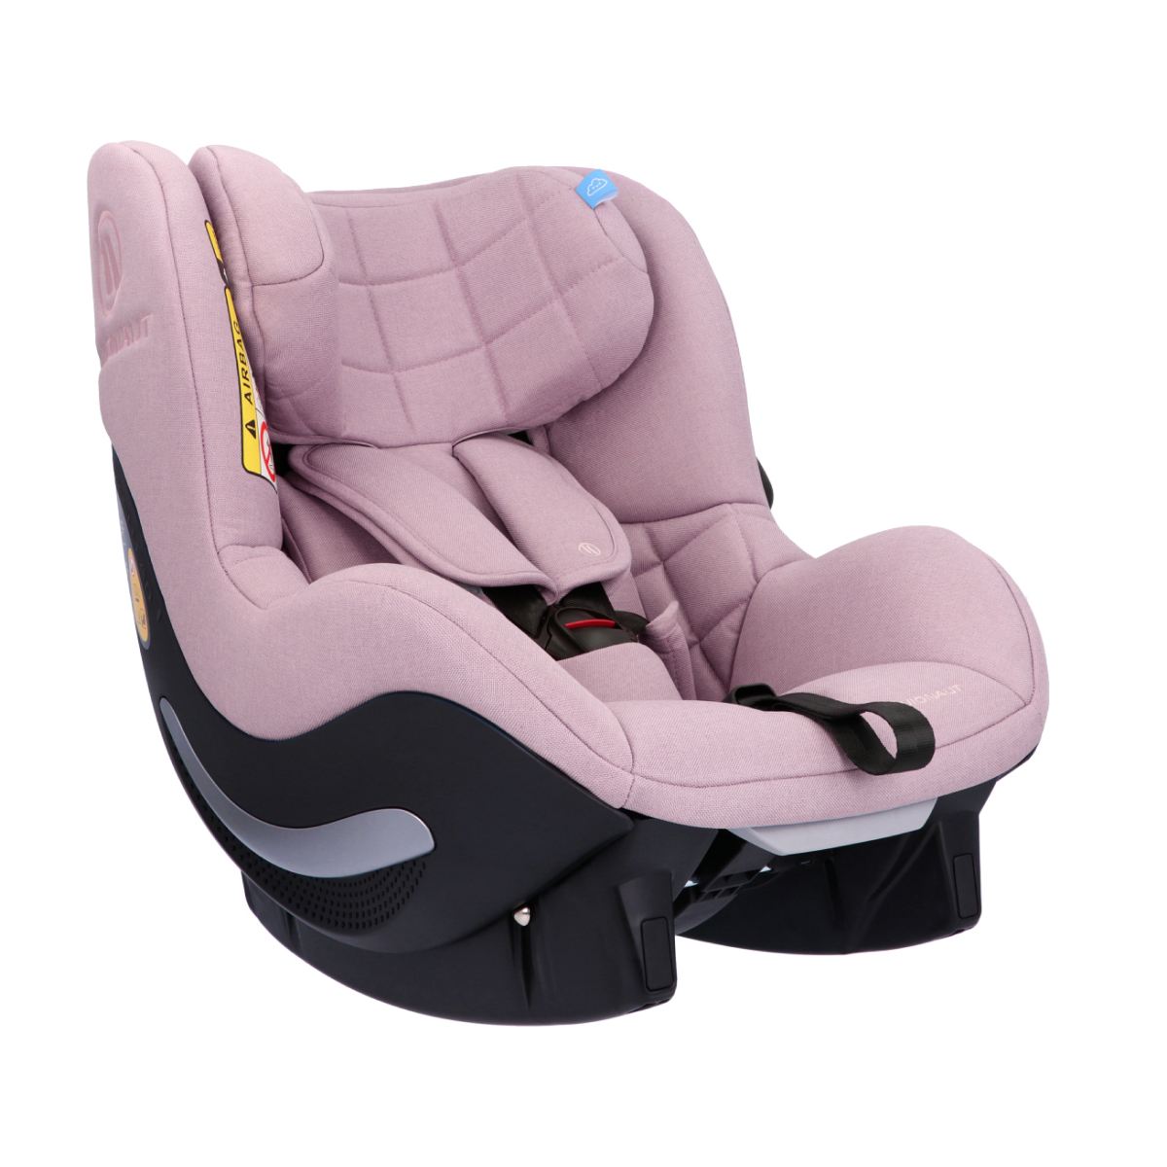 | 04182 AF.05  2.0 C | i-Size R.129,  67-105 cm  9-17,5 kg | 5907603461489 | 195 € | 329 €
Mint  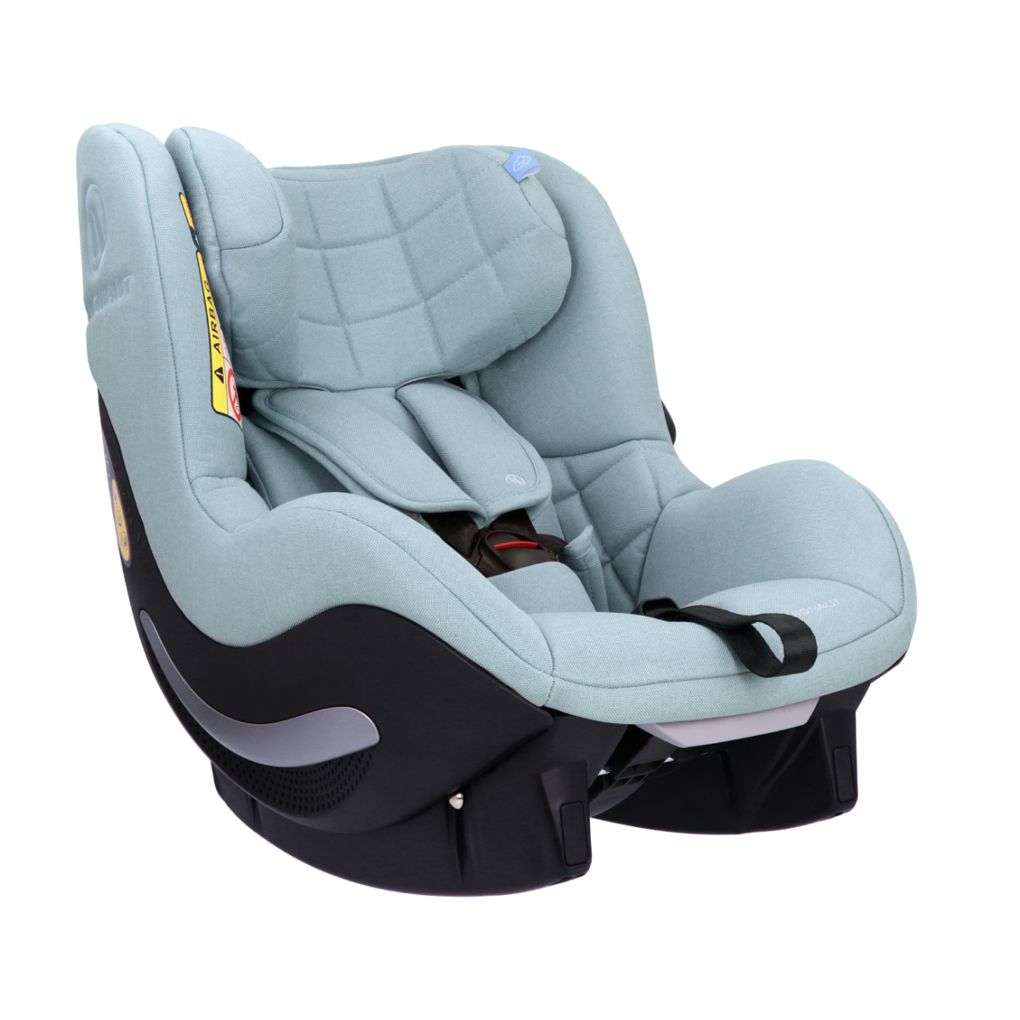 | 04183 AF.06  2.0 C | i-Size R.129,  67-105 cm  9-17,5 kg | 5907603461496 | 195 € | 329 €
Limited Edition  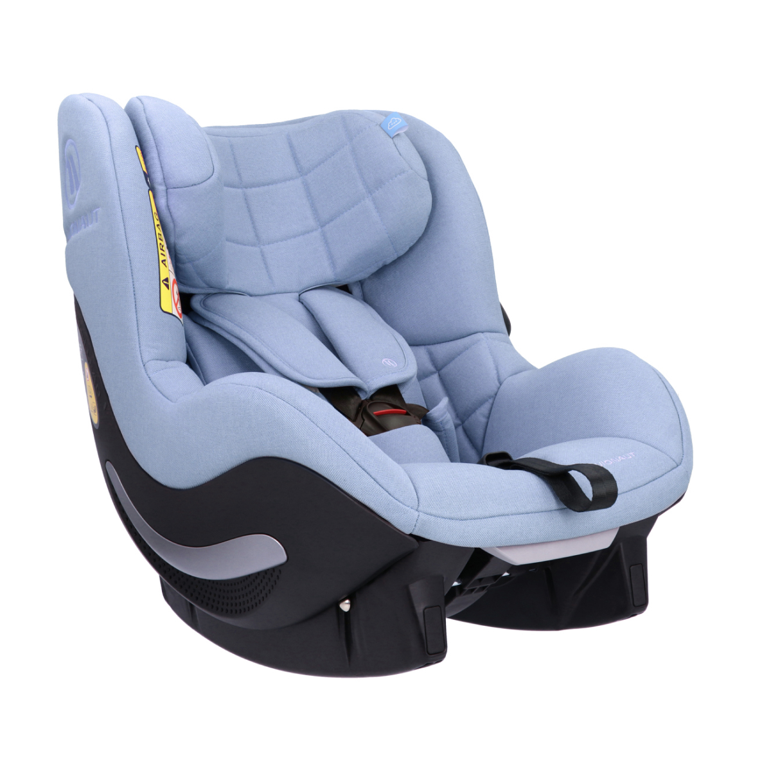 | 04418 AF.07  2.0 C | i-Size R.129,  67-105 cm  9-17,5 kg | 5907603461717 | 195 € | 329 €

AeroFIX RWF 2.0 C


Colour | Code | Parameters | EAN | Price | RRP | Ordered number
Grey   | 04184 AFR.01  2.0 C | i-Size R.129,  67-105 cm  9-17,5 kg | 5907603461502 | 195 € | 329 €
Beige   | 04185 AFR.02  2.0 C | i-Size R.129,  67-105 cm  9-17,5 kg | 5907603461519 | 195 € | 329 €
Black   | 04186 AFR.03  2.0 C | i-Size R.129,  67-105 cm  9-17,5 kg | 5907603461526 | 195 € | 329 €
Navy   | 04187 AFR.04  2.0 C | i-Size R.129,  67-105 cm  9-17,5 kg | 5907603461533 | 195 € | 329 €
Pink   | 04182 AF.05  2.0 C | i-Size R.129,  67-105 cm  9-17,5 kg | 5907603461540 | 195 € | 329 €
Mint   | 04189 AFR.06  2.0 C | i-Size R.129,  67-105 cm  9-17,5 kg | 5907603461557 | 195 € | 329 €
Limited Edition   | 04419 AFR.07  2.0 C | i-Size R.129,  67-105 cm  9-17,5 kg | 5907603461724 | 195 € | 329 €

Sky 2.0

Colour | Code | Parameters | EAN | Price | RRP | Ordered number
Grey  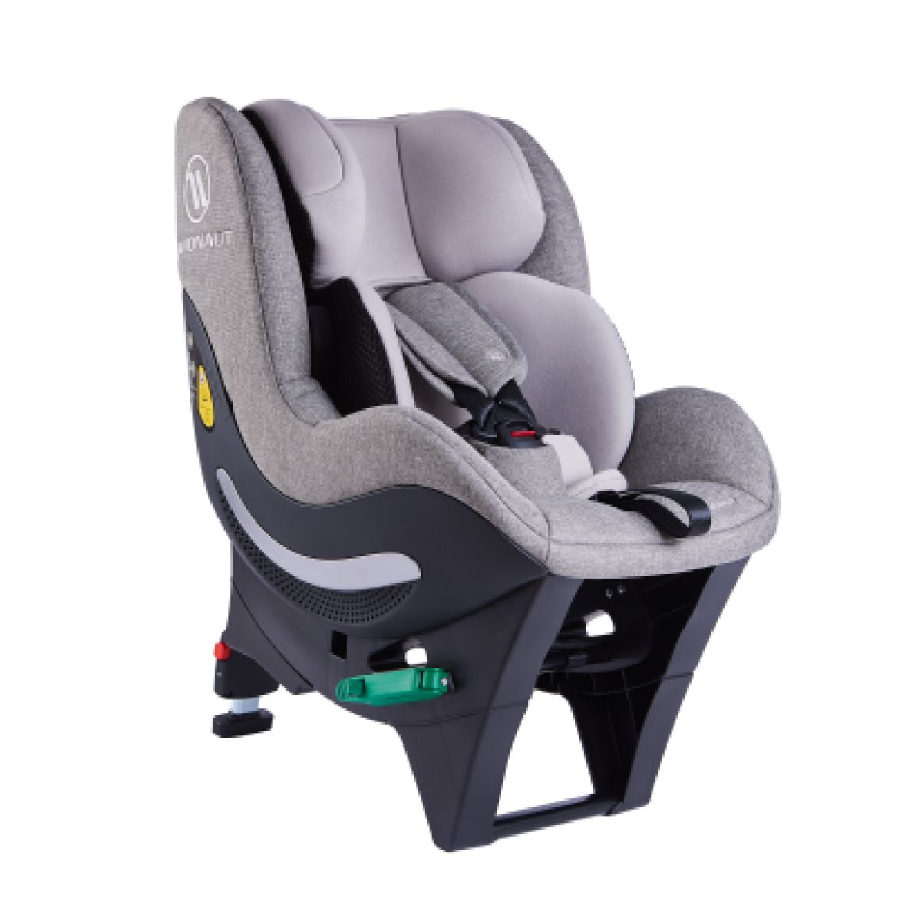 | AV-370/SKY.  NL.01 | R-129  40-125 cm  0-25 kg | 5907603465999 | 265 € | 439 €
Beige  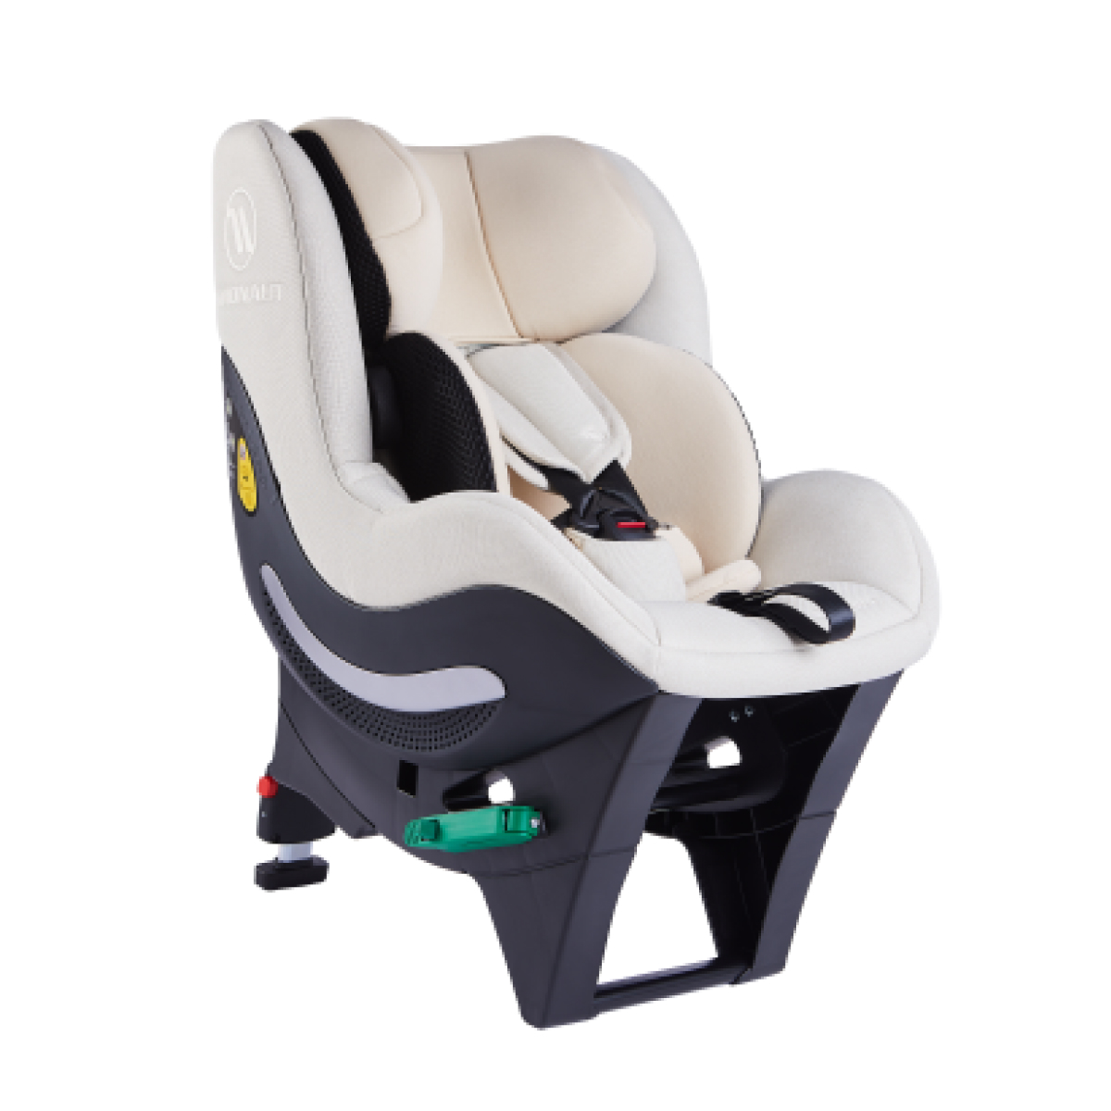 | AV-370/SKY.  NL.02 | R-129  40-125 cm  0-25 kg | 5907603466002 | 265 € | 439 €
Black  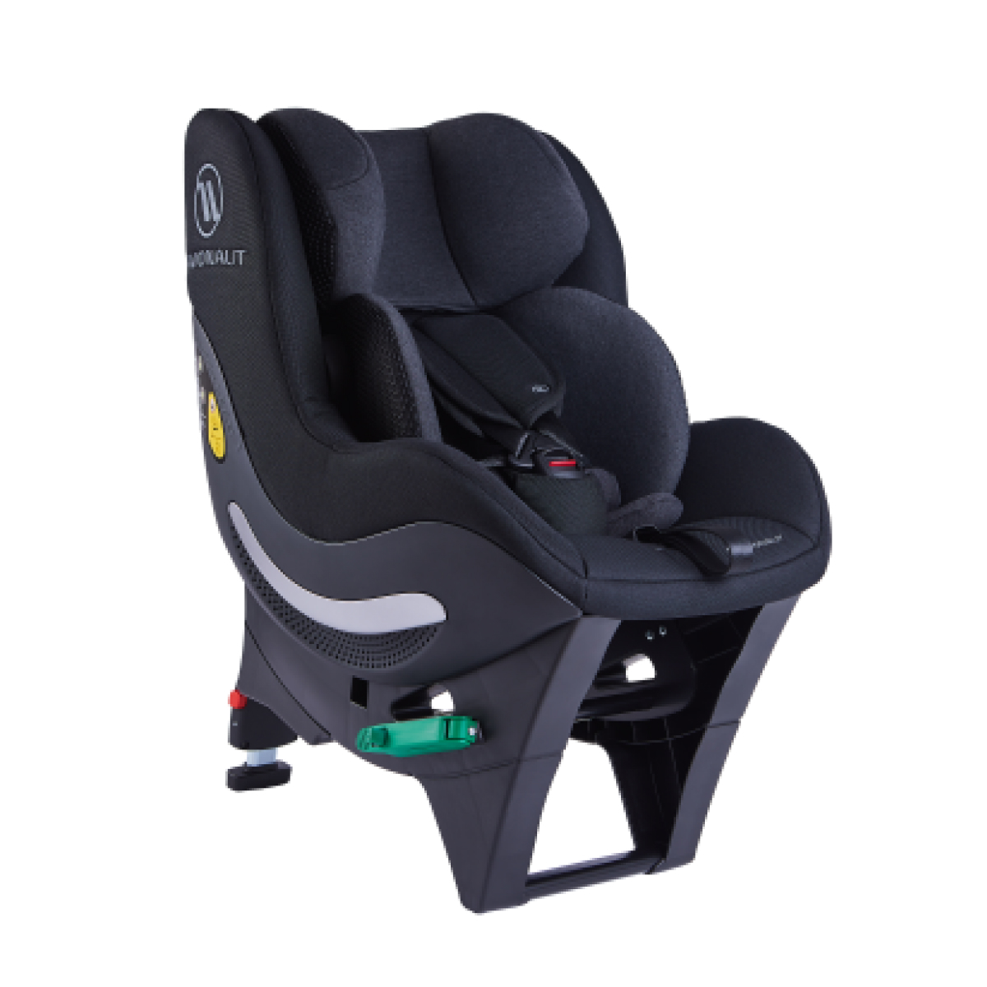 | AV-370/SKY.  NL.03 | R-129  40-125 cm  0-25 kg | 5907603466019 | 265 € | 439 €
Navy  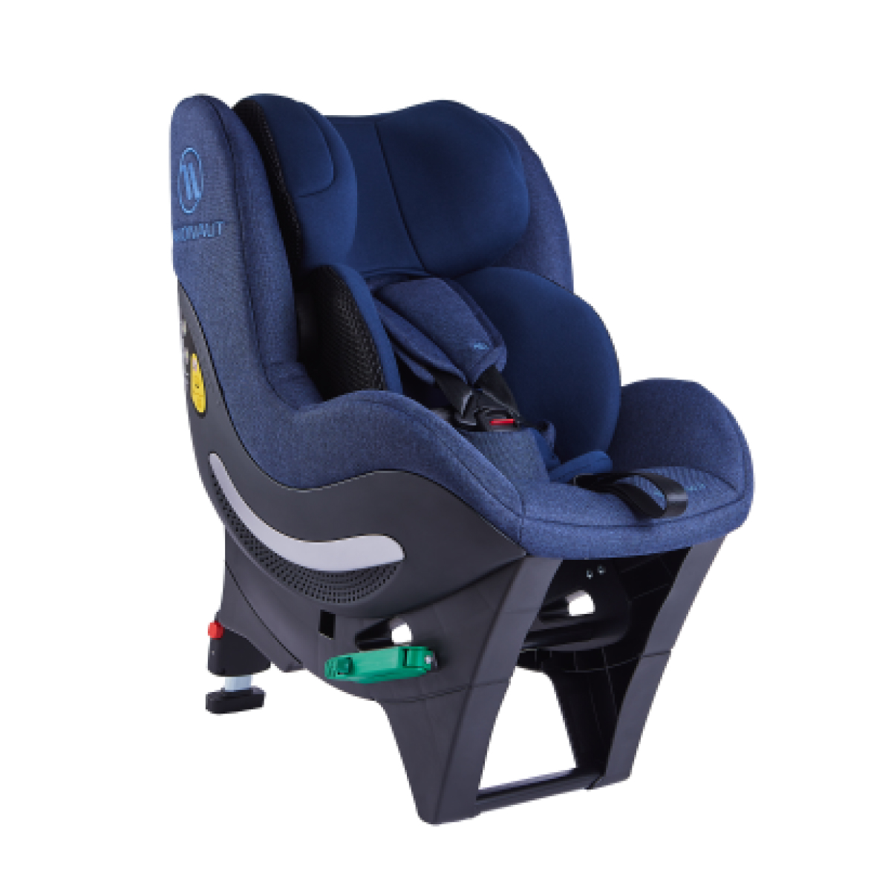 | AV-370/SKY.  NL.04 | R-129  40-125 cm  0-25 kg | 5907603466026 | 265 € | 439 €
Pink  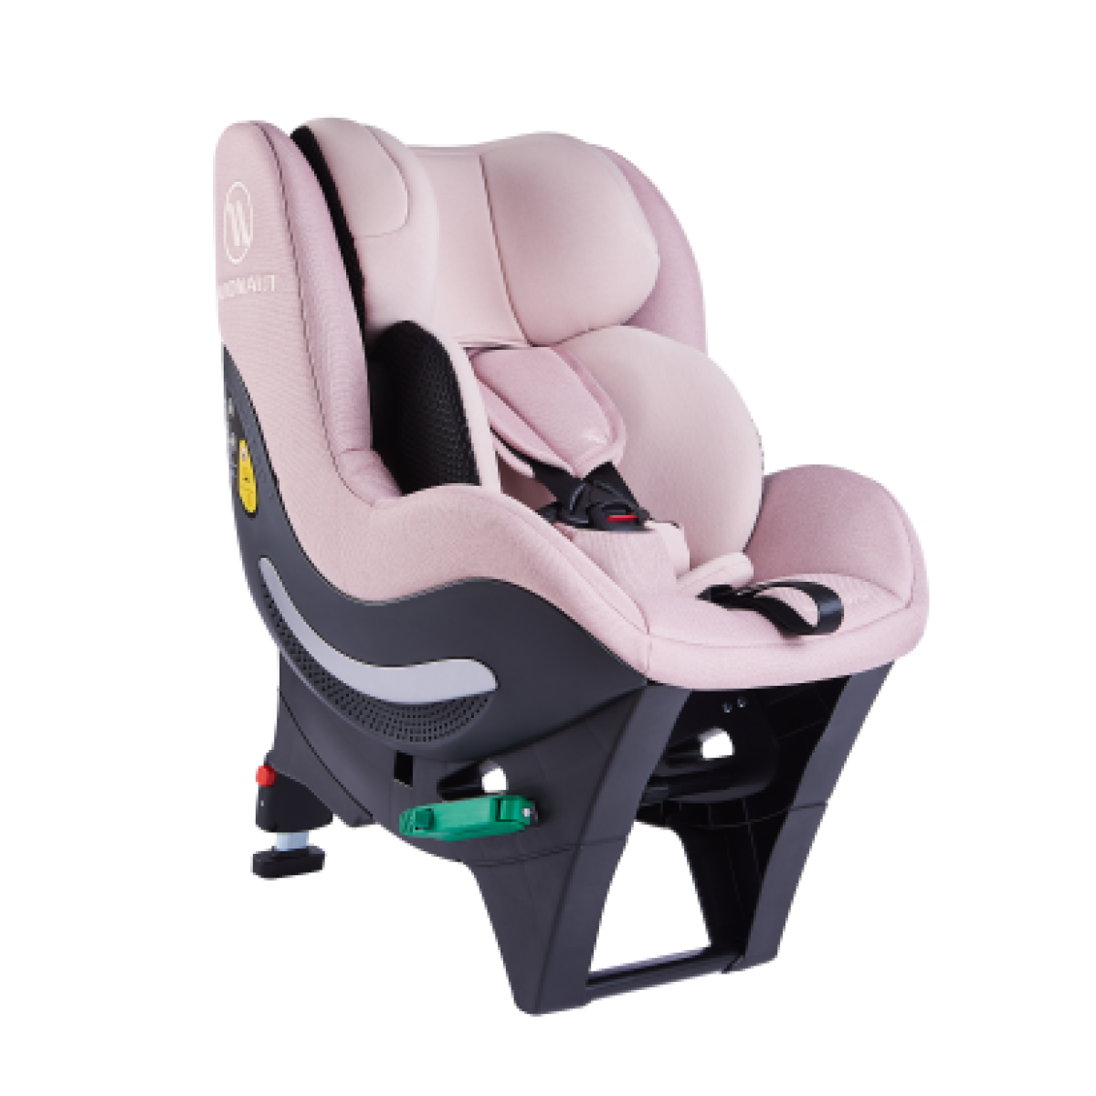 | AV-370/SKY.  NL.05 | R-129  40-125 cm  0-25 kg | 5907603466033 | 265 € | 439 €
Mint  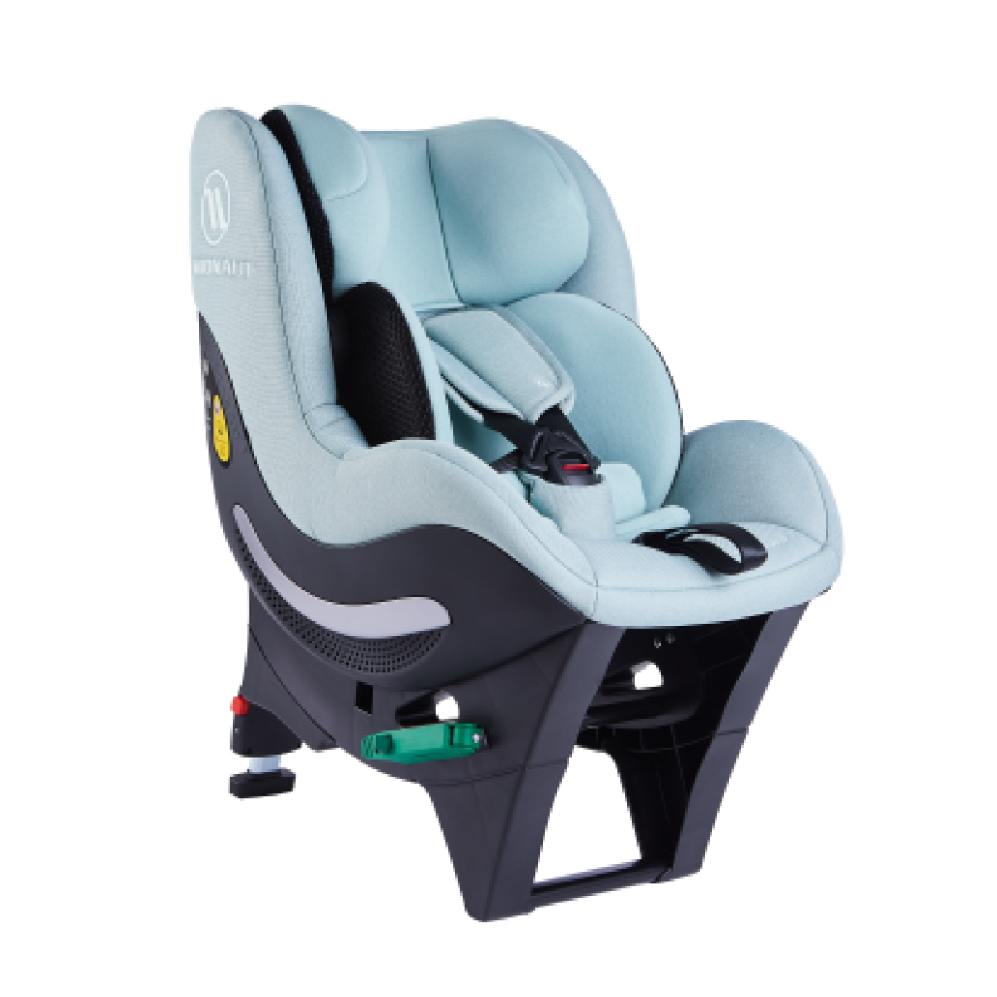 | AV-370/SKY.  NL.06 | R-129  40-125 cm  0-25 kg | 5907603466040 | 265 € | 439 €

Sky Q

Colour | Code | Parameters | EAN | Price | RRP | Ordered number
Grey | 22393 Baby Car Seat Avionaut SKY Q 2.0 New Look 0-25 kg/AV-370.Q/ SKY.NL.01.Q | R-129  67-125 cm  0-25 kg | 5907603461212 | 242 € | 369 €
Black | 22394 Baby Car Seat Avionaut SKY Q 2.0 New Look 0-25 kg/AV-370.Q/ SKY.NL.03.Q | R-129  67-125 cm  0-25 kg | 5907603461243 | 242 € | 369 €

Base IQ 2.0 C


Colour | Code | Parameters | EAN | Price | RRP | Ordered number
Black  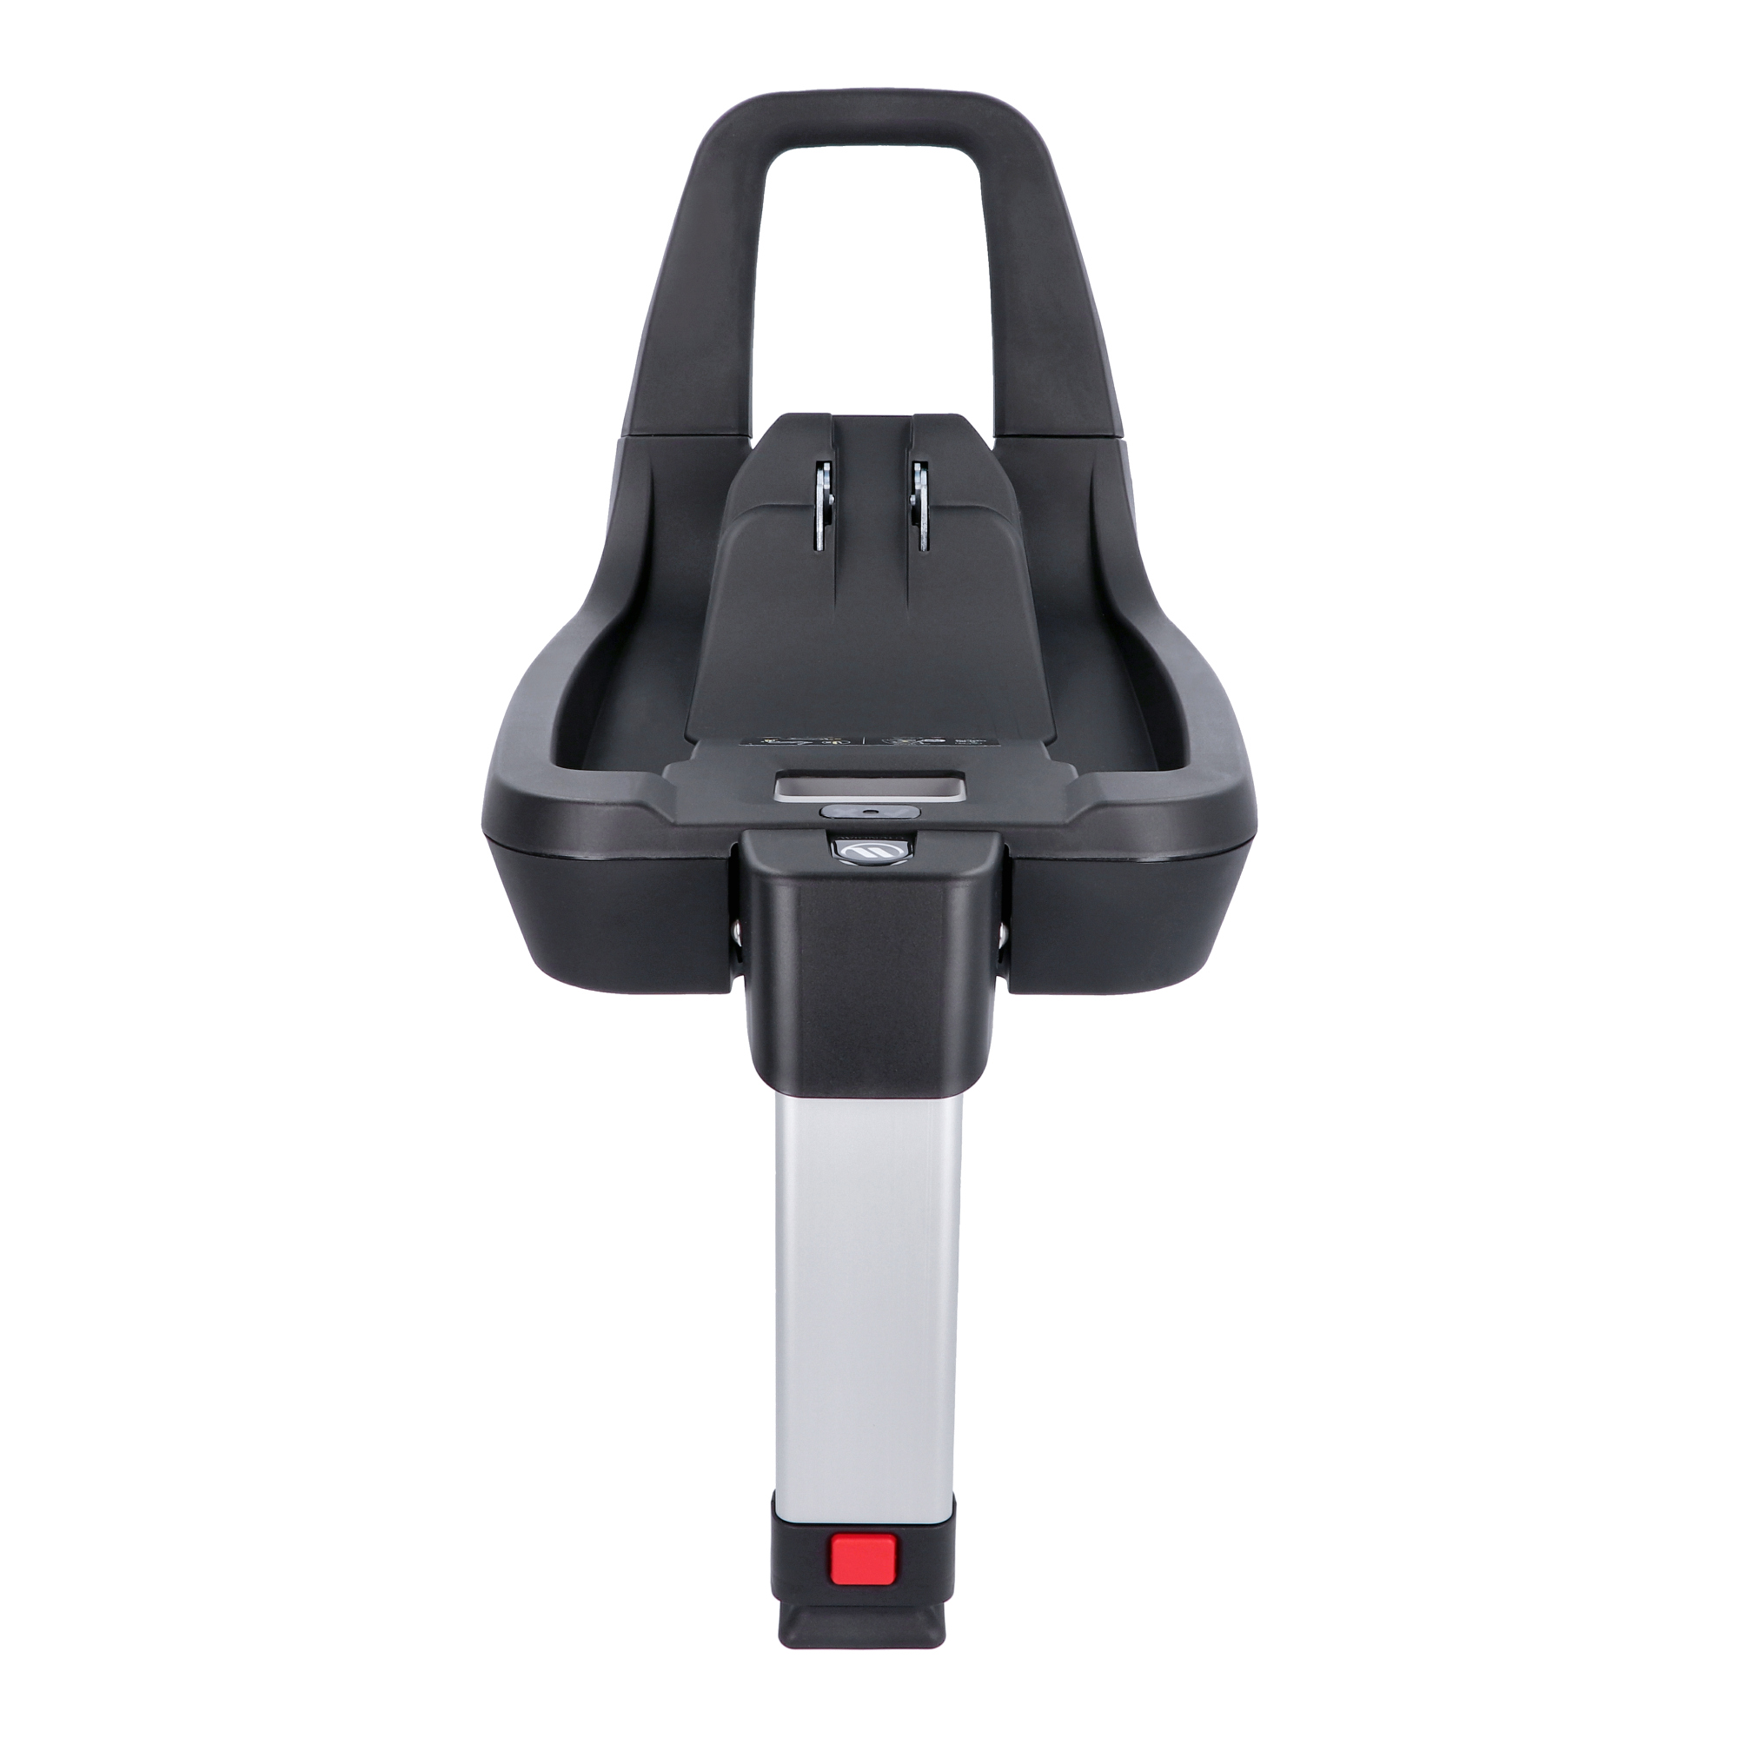 | 03862 AV-  -168,IQ 2.0 C | ISOFIX base | 5907603461199 | 152 € | 199 €

Dock 2 Base


Colour | Code | Parameters | EAN | Price | RRP | MOQ: 2 Stk.  Oder in Kombination mit der Avionaut Babyschale.  sonst zzg. 10 Euro Lieferkosten.
Black | 04527 AV-169/Base Dock 2 | ISOFIX base  0-13 kg | 5907603464107 | 93 € | 129 €

